TORKS TALK
February 2018
NOTICE!
OUR MEETING PLACE HAS CHANGED !!
NEW LOCATION:
Village United Methodist Church - 2501 W. Britton Rd.
Between May & Penn, on the NE Corner of Britton & Ridgeway Dr.
1st Stop light East of May
Park in the West Parking Lot, use the double doors under the Portico
March 6th 7:30 PM
Before you Fly in 2018-----
You MUST have a Valid 2018 AMA Card!
PAY your TORKS Dues. Gate Code will change February 1st.
You will receive the new code when Your Dues are Paid.
Reminder: The FAA regulations ARE STILL in EFFECT. Are You registered?

Mike’s Models on 11th and May, OKC has supported TORKS for 29 years let’s keep him in business.

February Club Meeting Highlights
Season Flyer Patch
At the February Club meeting, a suggestion was made to consider 12 consecutive months of flying a model and having the flight verified, would be counted as qualified for the ALL SEASON FLYER PATCH.
Starting with the first month that the member has a verified flight, any time of the year.
Our First (1st) Burger Burn and Fun Fly will be held APRIL 7th 2018, MARK YOUR CALANDER NOW.
MODEL of The Month
Mike McLish brought a Stearman PT-17 Bi-Plane for Show N Tell.

It’s February, It’s time to build something.
You may learn about all the basics of building your own model airplane. Start small with maybe a Guillows rubber power kit, or a small Control line kit, or a SIG LT-40 if you are getting into or back into Radio Control.
You will learn about Servos and Radio installation, Covering, Engine and fuel tanks, wheels, balance points, and all the other things that go into creating a Masterpiece.
There is no better feeling when someone says: ”Where did you get that Airplane ?”
And you answer: “I built it myself”

Nothing’s Uglier than a Stick
By Ken Kehlet AMA 1528

Famous Quotes:
Walk softly and carry a BIG STICK …….. Teddy Roosevelt
A Big Gun and a Stick is better than a Big Stick ….. Al Capone
A Big Stick with a .60 is better than a Big Stick with a .40, and A Little Stick with a .40 is better than no Stick at all……. Ken Kehlet
Kraft Radios:
Back in the early 1960s, Phil Kraft and Jerry Pullen teamed up to design and build some of the first reliable, Proportional REED R/C Radio systems. Several years later, in 1967, Phil Kraft took First Place in World Pattern Competition with the newly designed space age Proportional R/C system. Eight (8) of the top 10 places were won using Kraft Radio Systems.
Everyone wanted a Kraft System and orders were pouring into the new Vista California manufacturing facility. As new radios left the factory, CRASHED Receivers were coming back for repair.

The STICK:
Designed in 1965 by Phil Kraft, the “STICK” was to be used as a Test Bed for field testing of repaired Kraft R/C Receivers. It was just a flat bottom square body, 60” wing span, straight leading and tailing edge. No leading edge or center section sheeting. The trailing edge was made up of two (2) pieces of 1/8” X 2” Balsa, inset into the ribs and no cap strips. Straight Ailerons, and conventional Tail sections.
The Ailerons were controlled by one (1) servo mounted on the bottom center of the wing and two wire rods going out, Left and Right, to two 90 degree Bellcranks, mounted on the outside bottom surface of each wing. The rods exited the bottom of the wing where a “U” shaped notch was cut in each side of the fuselage at the wing saddle. The bellcrank rods were than attached to the Aileron Horns. Crude, but it worked very well and was easy to adjust
It seems that someone remarked that Phil had performed the impossible, he had designed and built an R/C model that was UGLIER than the Kraft KwikFli. The model was sure UGLY, but it flew great. It was so Ugly, everyone wanted a set of plans.
After seeing a photograph of a WW1 German Fokker Eindecker, George Walker, a friend of Phil, scribbled the outline of the Fin and the Rudder, Phil put the scalloped edged on the Elevator and the Ailerons, and they came up with a vague outline of a stand Way, Way, off Eindecker. George added the big iron crosses, Williams Brothers Machine Gun, and a Half Round Cowling made from an aluminum pot was the final touch. Thus the “DAS UGLY STICK” was created.
There were so many requests for plans that Phil and George were prompted to send the Plans and a construction article to “GRID LEAKS” magazine. ACE R/C was the owner of Grid leaks and the “DAS UGLY STICK” article and Plans were published in the summer of 1967.
Shortly thereafter, Jensen another friend of Phil and George, marketed the Das Ugly Stick R/C Kit for $24.95.
Kehlet had scratch built the “Das Ugly Stick” from one of Phil’s Plans before they were published in the Grid Leaks magazine. Yes, it crashed (Dumb Thumbs) with my brand new 1966 Kraft Custom Receiver inside, yes it was broken and the antenna was jerked out. I called the Kraft Factory in Vista and drove from Long Beach, California to get my Kraft Radio Receiver repaired.
That is when I met Phil Kraft, just for a few minutes, and one of his employees. The employee, Danny, checked my Transmitter and stated that it was all OK, he put power to a new receiver and checked it out. We went outside and put the new receiver into: what else ? one of three (3) beat up Ugly Sticks that were used for test flying. He collapsed the Transmitter antenna and proceeded to fly the model. He said “No charge” and I was happy.
It was then that I offered to repair their Ugly Stick models. Instead, I was offered $350.00 to build… that is to Frame-up, Twelve (12) Ugly Stick airplanes from Jensen Kits. I delivered the first 3 in less than 2 weeks and got paid the full $350.00.
Between June of 1967 and December of 1968 I framed up a total of 36 Jensen Ugly Stick models and delivered all of them to the Kraft Factory. Yes, I did build 36 Das Ugly Stick models for Phil Kraft.
In the last 50+ years, there has been more variations of Phil Kraft’s Das Ugly Stick than any other R/C model. Jensen kitted the first design, Midwest kitted a series of Sticks; Little Stick, Sweet Stick, Super Sweet Stick, Sweet and Low Stick, Bipe Stick, Twin Stick, Canard Stick, and the Aero Sport Stick. Balsa USA offered their Swizzle Sticks. Orline produced the Victory Stick, Hobby Shack kitted the Giant Stick and the Joss Stick, RPM kitted the Liberty Stick and the Lucky Stick, a 1/2A Stick and the Littlest stick were produced by ACE R/C, Great Planes still produces their kits and ARF Big Stick .20, .40 and .60, and Thunder Tiger had their Tiger Stick.
The “Das Ugly Stick” hasn’t changed much in the last 50+ years, and it looks like it’s still going strong.
Remember: Walk softly and carry a Big Stick, and a Transmitter, a Flight box, Ni-Starter, Electric Starter, Fuel, Extra Props, Plug Wrench, cleaner and paper towels, Etc, Etc.
An Ugly Stick and a Veco or K&B .61 was a winning combination for many Pattern and Fun Fly contests, also made a very stable R/C Trainer with a .40 - .45 engine
But: Please do it SAFELY, Cold Weather tends to cause Careless quick motions of hands. Fast spinning Propellers are Immune to Careless Fingers.
Keep Em Flying SAFE,
Ken Kehlet AMA 1528
Mike’s Models on 11th and May, OKC has supported TORKS for 29 years let’s keep him in business.
BUY SOMETHING !
BUILD SOMETHING !

TORKS OFFICERS for 2018
President
Mark Grennan
(405) 343-9332
mark@grennan.com
Vice President
Mike Scanlon
(405) 226-5336
mscan584@cox.net
Secretary and Newsletter Editor
Mike McLish
(405) 519-2580
cuestick54@gmail.com
Treasurer
George Burton
(405) 202-3409
okctorks@yahoo.com
Safety Officer and
Lead Instructor
Gary Crews
(405) 245-3424
crewsgw@cox.net
TORKS FIELD MANAGER
Willard Eshbaugh
(405) 947-5128 eskimookc@yahoo.com
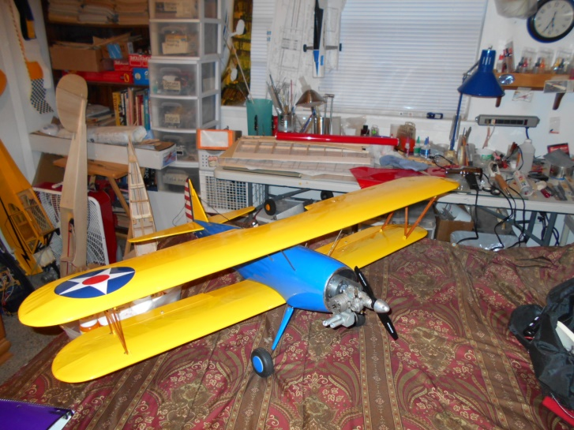Mike’s PT-17
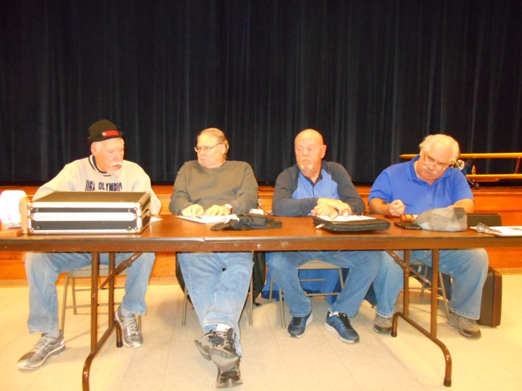
What did you say? Please repeat that, I don’t have my hearing aids in tonight. 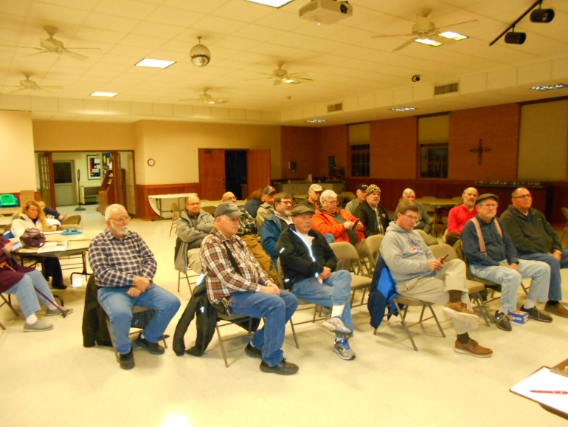
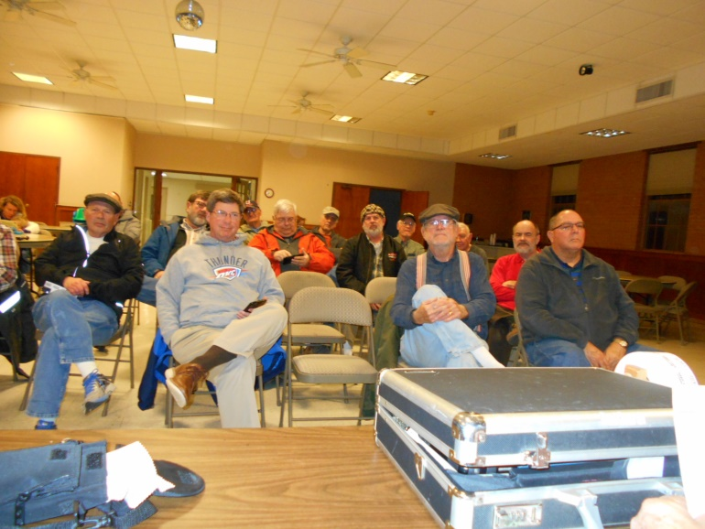
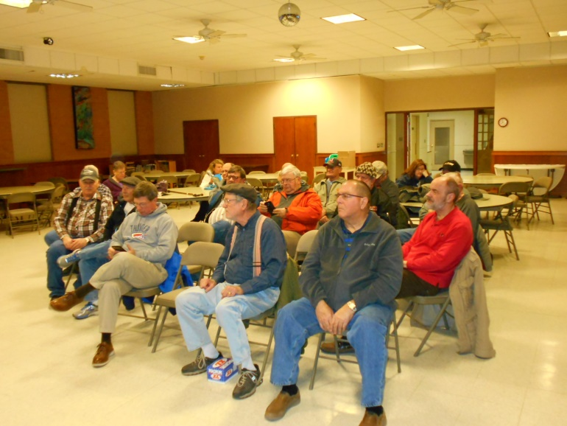
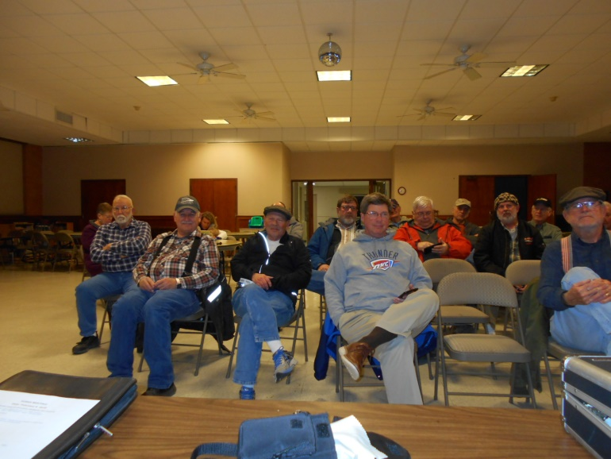

Another “AA” Meeting went wrong. Better luck next month
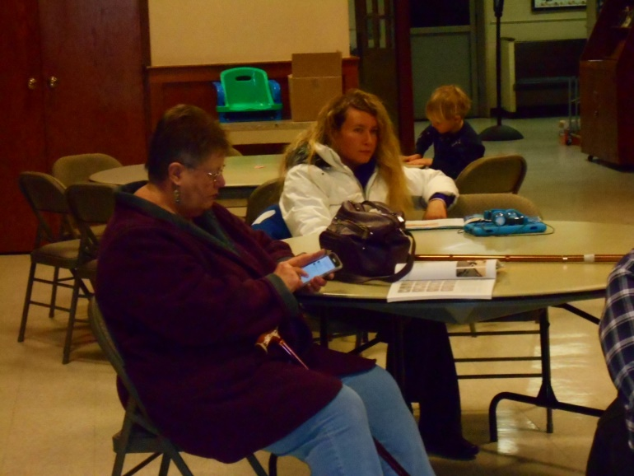

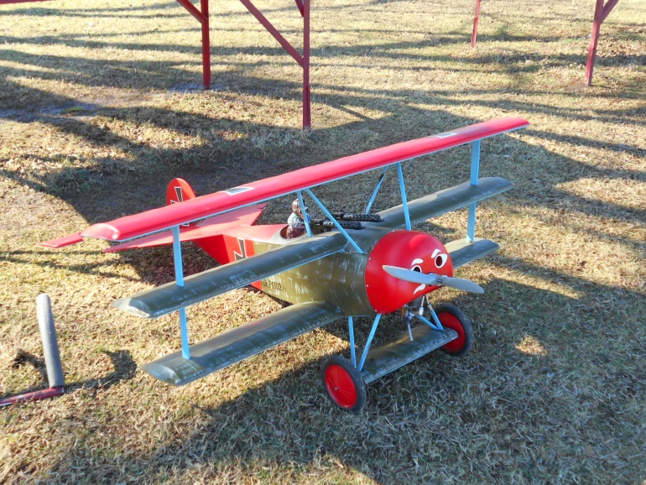
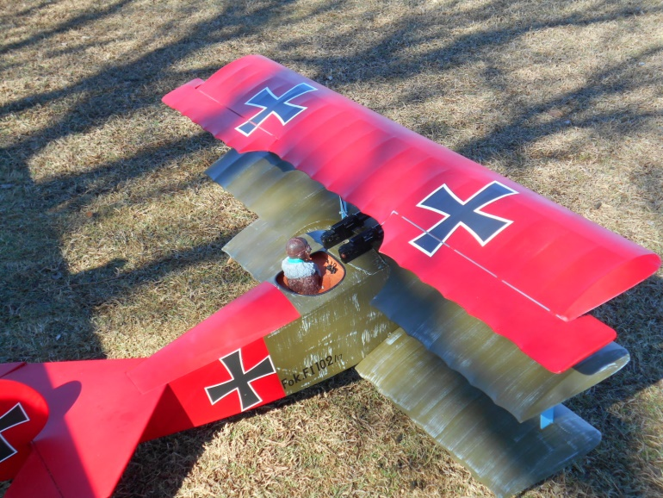
Rick Hunter’s DR-1 1/4 Scale

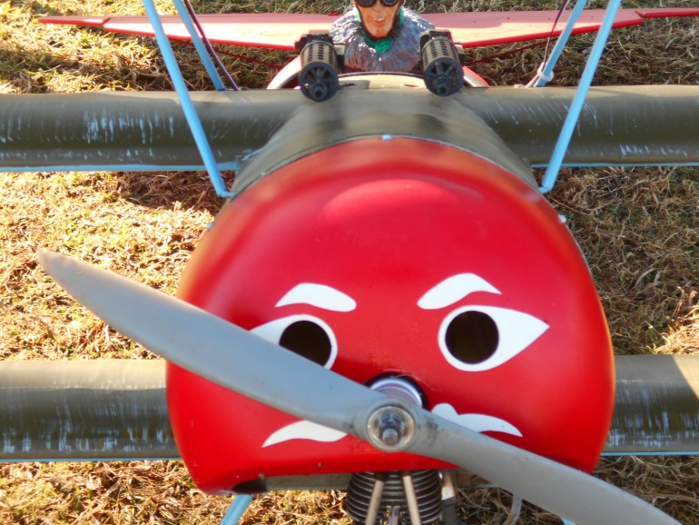
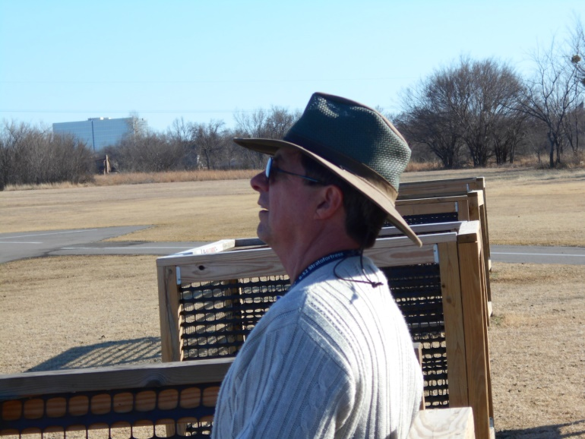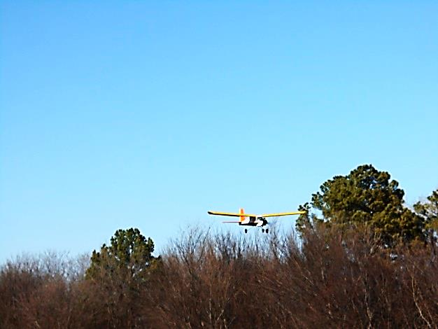
Gary Crews and the LT-40
TORKS TALK Is written and edited by Mike McLish (cuestick54@gmail.com)

